THEORY QUESTIONS

SECTION I

THE ENVIRONMENT
1.
a)

Use the sketch map of the world to answer this question
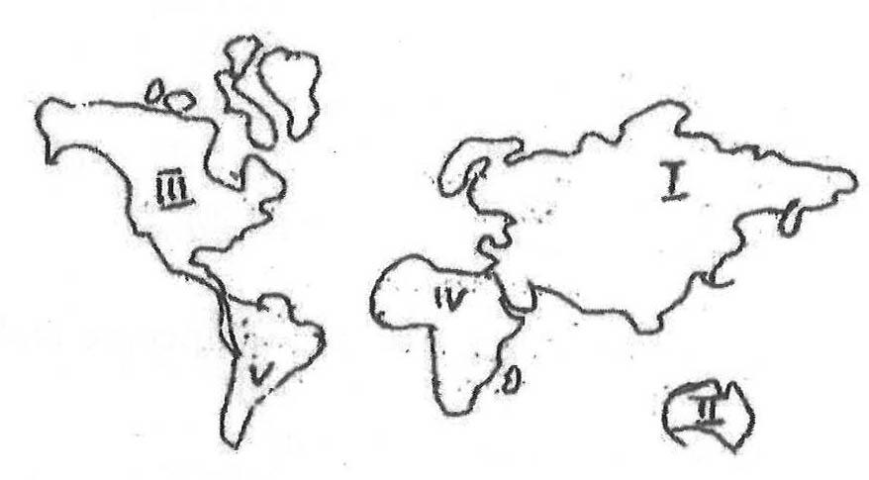
Identify the continents labelled I, II, III, IV and IV
b)

What do the following conventional signs represent on a map?
i)

Fm
ii)


iii)

Ct. H
c)

With the aid of a diagram, describe how day and night are caused.

2.
a)

Define the following:
i)

adolescence;
ii)

reproductive health.
b)

Outline four factors that can promote good adolescence reproductive health.

SECTION II

GOVERNMANCE, POLITICS AND STABILITY
3.
a)

Draw a diagram showing the traditional government structure in Ghana.
b)

State four duties of a chief in the community.
c)

Highlight four duties of an Assembly man in your community.

4.
a)

Outline four reasons for which the Fante confederation was formed.
b)

Highlight four achievements of Sir Frederick Gordon Guggisberg in the Gold Coast.

SECTION III

SOCIAL AND ECONOMIC DEVELOPMENT
5.
a)

i)

List four types of natural resources in Ghana
ii)

Give an example each of the natural resources listed in (a)(i)
b)

In what four ways can the use of natural resources in Ghana be sustained?

6.
a)

i)

Distinguish between education and training.
ii)

List four examples of primary production.
b)

In what four ways can productivity at work places be improved in Ghana?

